**CACIE Tool #01** – ***Tool Runner (runner.py)***

**Version** **1.0**

**QA**: **QA**

1. **Description and Purpose**

The Tool Runner acts as a controller for all the other utilities contained within the CACIE tool set. The Tool Runner determines configuration control status of an invoked tool and documents its version and QA status (i.e., whether or not the invoked tool has been tested and qualified in compliance with the CACIE Integrated Software Management Plan).

1. **Functional Requirements**

The following are the functional requirements of the Tool Runner.

FR-1: Invoke tool with required arguments

FR-2: Document user, computer, operating system platform, and date/time

FR-3: Verify and document the QA Status of the Tool Runner and the invoked tool

The QA Status of the Tool Runner and the invoked tool is based on fulfilling the following functional requirements:

FR-4: Verify and document that the Tool Runner and the invoked tool are located in a git version-controlled repository and if so, document the code version of the Tool Runner and invoked tool

FR-5: Determine if the local git repository branch is the “master” branch and the files are consistent with the remote master branch (i.e. “nothing to commit, working tree clean”)

FR-6: Determine if the local git repository branch version is the same version as a released and tagged version of the remote master branch

FR-7: Determine if Tool Runner and the invoked tool are on a maintained approved tool list.

1. **Software Requirements Specifications**

Git version 2.21.0 (Windows) or 2.24.0 (Linux)

Python 3.5

Python Standard Libraries:  
argparse  
datetime  
getpass  
json  
logging  
os  
pathlib  
platform  
socket  
subprocess   
sys

Modules:  
.\constants.py  
.\config.py (.\constants.py, pylib\config\config.py, pylib\autoparse\autoparse.py)  
pylib\info\info.py  
pylib\pygit\git.py

1. **Software Design Description**

The following is a brief description of the required arguments and the output generated by the Tool Runner.

* Positional Arguments:
  + Name: the filename of tool to be invoked (if tool is an executable, tool_filename.exe) or the command (perl, python, java) required to execute the tool; enclose in quotes
  + Arguments: the filename of the tool to be invoked (if a python or perl script or JAVA program) and/or the tool-specific arguments to be passed to the tool (see documentation associated with each tool); enclose in quotes
* Optional Arguments:
  + -h, --help show help message
  + --loglevel {I,D} verbosity of log: (I)nfo, (D)ebug; default=I
  + --logfile LOGFILE path to a log file (default is stdout)
  + -- logfilemode {a,w} Log file mode: (a)ppend or (w)rite; default=w
* Shell file configuration:

python [directory path]/pylib/runner/runner.py [optional arguments—see above] “Name” “Arguments”

* Output: The following information is logged to the screen (default, i.e. stdout) or to a path and file, which is specified by user and is passed to the Tool Runner as an argument (--logfile LOGFILE)
* DateTime stamp of when Tool Runner is invoked and where information is being logged
* Invoked command and arguments
* Code Version of Tool Runner
* Code Version of invoked tool
* QA Status of Tool Runner
* QA Status of invoked tool
* Username and the computer and platform used to invoke the Tool Runner and invoked tool

An independent code inspection was performed by Mitchell Tufford on 11/22/2019. Dependencies on shared modules are identified in Section 4 and include pylib\config\config.py, pylib\autoparse\autoparse.py, pylib\info\info.py, and pylib\pygit\git.py. Functional changes to these modules as part of another tool will require retesting of the Tool Runner to ensure the changes do not impact the functionality of the Tool Runner.

1. **Requirements Traceability Matrix**

The requirements traceability matrix for the Tool Runner is presented in Table 1.

| **Table 1. Tool Runner Requirements Traceability Matrix** | | |
| --- | --- | --- |
| **Functional Requirement ID** | **Acceptance Test ID** | **Test Case** |
| QA Level | CACIE-runner.py -IT-1 | Installation Test |
| FR-1 FR-2 FR-3 FR-4 FR-5 FR-6 FR-7 | CACIE-runner.py-TC-1 | Invoked tool is QA-approved |
| FR-3 FR-4 | CACIE-runner.py-TC-2 | Tool Runner and invoked tool are not located in a GIT repository |
| FR-3 FR-5  FR-7 | CACIE-runner.py-TC-3 | Local repository has been modified (not consistent with remote repository) |
| FR-3 FR-6  FR-7 | CACIE-runner.py-TC-4 | Local git repository branch version is the same version as the remote “master” branch; |

1. **Test Plan and Cases**

The installation test plan for the Tool Runner is presented in Table 2 and the acceptance test plan cases are in Table 3 through Table 6. The steps are to be executed on a Linux platform and on a Windows platform.

| **Table 2. Tool Runner Installation Test Plan** | | | |
| --- | --- | --- | --- |
| **Tool Runner Installation Testing**  **CACIE-runner.py – IT-1** | | **Date:** | |
| **Tool Runner File Location for this test:** | | **Test Performed By: [FIRST & LAST NAME]** | |
| **Testing Directory:** | | | |
| **TEST ID** | **Test Case** | | **Test Result  (Pass/Fail)** |
| *NOTE: [linux.sh] extension for Linux platform*  *NOTE: [windows.bat] extension for Windows platform* | | | |
| CACIE-runner.py -IT-1 | *Navigate to [Testing_Directory]* | | |
| *Invoke Tool Runner and test tool as follows:*  *Enter the following command: ./runner_run_IT-1_[linux.sh][windows.bat]* | | |
| Verify Tool Runner is invoked and executes | |  |
| Verify invoked tool executes | |  |

| **Table 3. Tool Runner Acceptance Test Plan Case 1** | | | |
| --- | --- | --- | --- |
| **Tool Runner Acceptance Testing**  **CACIE-runner.py – TC-1** | | **Date:** | |
| **Tool Runner File Location for this test:** | | **Test Performed By: [FIRST & LAST NAME]** | |
| **Testing Directory:** | | | |
| **TEST ID** | **Test Case** | | **Test Result  (Pass/Fail)** |
| *Note [*Test_Repo_Name*] in acceptance test report*  *Note [Testing_Directory] in acceptance test report* | | | |
| *If testing on Windows, open git bash window in [Test_Repo_Name].*  *If testing on Linux, navigate to [Test_Repo_Name].*  *Ensure git repository is on “master” branch by entering:*   * *git branch*   *if not on “master” enter the following command:*   * *git checkout master*   *Enter the following command:*  *git pull*  *NOTE: [linux.sh] extension for Linux platform*  *NOTE: [windows.bat] extension for Windows platform* | | | |
| CACIE-runner.py-TC-1 | *Navigate* to [Testing_Directory]\ca*-surf-test\ subdirectory* | | |
| *Invoke Tool Runner and test tool using runner_run_ATC-1.[sh][bat] as follows:*  *Enter the following command: ./runner_run_ATC-1.[sh][bat]* | | |
| Verify that the [Testing_Directory]\runner_ATC-1_logfile.txt documents user, computer, operating system platform, and datetime stamp | |  |
| Verify that [Testing_Directory]\runner_ATC-1_logfile.txt documents the code version of the Tool Runner and test tool | |  |
| Verify [Testing_Directory]\runner_ATC-1_logfile.txt documents that the Tool Runner QA Status is TEST  NOTE: Tool Runner is not on the approved tool list in the test repository—see [Test_Repo_Name]\pylib\runner\config.json to verify | |  |
| Verify that [Testing_Directory]\runner_ATC-1_logfile.txt documents that the invoked tool QA Status is QUALIFIED  NOTE: Invoked tool is on the approved tool list in the test repository—see [Test_Repo_Name]\pylib\runner\config.json to verify | |  |

| **Table 4. Tool Runner Acceptance Test Plan Case 2** | | | |
| --- | --- | --- | --- |
| **Tool Runner Acceptance Testing**  **CACIE-runner.py – TC-2** | | **Date:** | |
| **Tool Runner File Location for this test:** | | **Test Performed By: [FIRST & LAST NAME]** | |
| **Testing Directory:** | | | |
| **TEST ID** | **Test Case** | | **Test Result  (Pass/Fail)** |
| CACIE-runner.py-TC-2 | *Navigate* to [Testing_Directory]\ca*-surf-test\ subdirectory* | | |
| *Invoke Tool Runner and test tool using runner_run _ATC-2.[sh][bat] as follows:*  *Enter the following command: ./runner_run_ATC-2.[sh][bat]* | | |
| Verify that [Testing_Directory] \runner_ATC-2_logfile.txt documents that the Tool Runner and test tool are not located in a Git Repository ( ../tools/ subdirectory) | |  |
| Verify that runner_ATC-2_logfile.txt documents that the Tool Runner and test tool QA Status is TEST | |  |

| **Table 5. Tool Runner Acceptance Test Plan Case 3** | | | |
| --- | --- | --- | --- |
| **Tool Runner Acceptance Testing**  **CACIE-runner.py – TC-3** | | **Date:** | |
| **Tool Runner File Location for this test:** | | **Test Performed By: [FIRST & LAST NAME]** | |
| **Testing Directory:** | | | |
| **TEST ID** | **Test Case** | | **Test Result  (Pass/Fail)** |
| CACIE-runner.py-TC-3 | *Navigate to the [*Test_Repo_Name*] and add addfile.txt file to directory* | | |
| *Navigate to [Testing_Directory]\ca-surf-test\ subdirectory* | | |
| *Invoke Tool Runner and test tool using runner_run _ATC-3.[sh][bat] as follows:*  *Enter the following command: ./runner_run_ATC-3.[sh][bat]* | | |
| Verify that [Testing_Directory]\runner_ATC-3_logfile.txt documents that the Tool Runner and test tool QA Status is TEST | |  |
| *Delete addfile.txt file from directory* | | |
| *Invoke Tool Runner and test tool using runner_run _ATC-3.[sh][bat] as follows:*  *Enter the following command: ./runner_run_ATC-3.[sh][bat]* | | |
| Verify that runner_atc_testing_model\runner_ATC-3_logfile.txt documents that Tool Runner QA Status is TEST  NOTE: Tool Runner is not on the approved tool list in the test repository—see \[Test_Repo_Name]\pylib\runner\config.json to verify | |  |
| Verify that runner_atc_testing_model\runner_ATC-3_logfile.txt documents that the invoked tool QA Status is QUALIFIED  NOTE: Invoked tool is on the approved tool list in the test repository—see [Test_Repo_Name]\pylib\runner\config.json to verify | |  |
| *Navigate to [Test_Repo_Name]* | | |
| *Enter the following command:*   * *git checkout development* | | |
| *Navigate to [Testing_Directory] \ca-surf-test* | | |
| *Invoke Tool Runner and test tool using runner_run_ATC-3.[sh][bat] as follows*  *Enter the following command: ./runner_run_ATC-3.[sh][bat]* | | |
| Verify that *[Testing_Directory]*\runner_ATC-3_logfile.txt documents that the Tool Runner and test tool QA Status is TEST | |  |
| *Navigate to [*Test_Repo_Name*]* | | |
| *Enter the following command:*   * *git checkout master* | | |

| **Table 6. Tool Runner Acceptance Test Plan Case 4** | | | |
| --- | --- | --- | --- |
| **Tool Runner Acceptance Testing**  **CACIE-runner.py – TC-4** | | **Date:** | |
| **Tool Runner File Location for this test:** | | **Test Performed By: [FIRST & LAST NAME]** | |
| **Testing Directory:** | | | |
| **TEST ID** | **Test Case** | | **Test Result  (Pass/Fail)** |
| *CACIE-runner.py-TC-4* | *Navigate to the [*Test_Repo_Name*] and add file addfile.txt to directory* | | |
| *Enter the following commands:*   * *git add addfile.txt* * *git commit -m ‘test commit’* | | |
| *Navigate to [Testing_Directory] \ca-surf-test* | | |
| *Invoke Tool Runner and test tool as follows:*  *Enter the following command: ./runner_run_ATC-4.[sh][bat]* | | |
| Verify that [Testing_Directory]\runner_ATC-4_logfile.txt documents that the Code Versions indicate that that local and remote repositories are not synced | |  |
| Verify that [Testing_Directory] \runner_ATC-4_logfile.txt documents that the Tool Runner and test tool QA Status is TEST | |  |
| *Navigate to [*Test_Repo_Name*]* | | |
| *Enter the following commands:*   * *git log -2* * *git reset --hard [first 6 characters of second commit SHA-1 hash]* | | |
| *Navigate to [Testing_Directory] \ca-surf-test* | | |
| *Invoke Tool Runner and test tool using runner_run _ATC-4.[sh][bat] as follows:*  *Enter the following command: ./runner_run_ATC-4.[sh][bat]* | | |
| Verify that [Testing_Directory] \runner_ATC-4_logfile.txt documents that the local repository and remote repository versions are the same (no “not synced message”) | |  |
| Verify that [Testing_Directory] \runner_ATC-4_logfile.txt documents that Tool Runner QA Status is TEST  NOTE: Tool Runner is not on the approved tool list in the test repository—see \[Test_Repo_Name]\pylib\runner\config.json to verify | |  |
| Verify that [Testing_Directory] \runner_ATC-4_logfile.txt documents that the invoked tool QA Status is QUALIFIED  NOTE: Invoked tool is on the approved tool list in the test repository—see \[Test_Repo_Name]\pylib\runner\config.json to verify | |  |

See appendix for the corresponding acceptance test case test logs as noted in the test case descriptions.

1. **Acceptance Test Report**

Acceptance testing of the Tool Runner was performed by Neira Mondragon on 12/09/2019 and 12/10/12019 and in accordance with the test plan documented in Section 6. The acceptance testing was performed in the following directories:

\\olive\backups\CAVE\sara-sandbox\ToolsTesting\ runner_atc_testing_model_linux

\\olive\backups\CAVE\sara-sandbox\ToolsTesting\ runner_atc_testing_model_windows

The test repository was located in the following directory:

\\olive\backups\CAVE\sara-sandbox\ToolsTesting\TEST_CACIE

The Tool Runner met the functional requirements as documented in Section 2. Verification of the tool’s functionality is documented in Table A-1 through Table A-8 and the test logs included in Appendix A.

During testing on a Windows platform, it was identified that a system path variable is required in order to allow the tool to execute a git command. The system path variable corresponds to the directory path where the git.exe is located on the user’s machine. It was also identified that the Tool Runner must be executed from a mapped drive location on the user’s machine when it is invoked on a Windows platform (i.e., UNC paths are not compatible with the Tool Runner). This information has been included in Section 8, User Guide.

1. **User Guide**

The Tool Runner will be invoked from the command line using a customized shell script for each invoked tool. The shell script will include the arguments for the Tool Runner as specified in Section 4 (Software Design) and the arguments for the invoked tool.

Use of the Tool Runner on a Windows platform requires a system path variable corresponding to the directory path for the git.exe file. Additionally, the Tool Runner must be executed from a mapped drive location on the user’s machine when used on a Windows platform.

1. **Tool Versions**

This section details changes incorporated into each version of the Tool Runner tool.

• 1.0 – Tool was developed.

**Appendix A**

**Acceptance Testing Logs**

**Tool Runner Log**

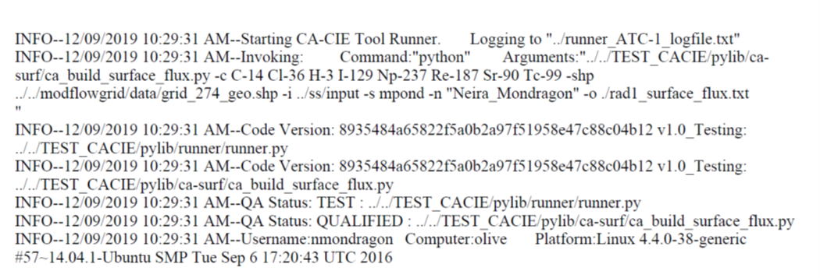

| **Table A-1. Tool Runner Acceptance Test Plan Case 1: Linux Platform** | | | |
| --- | --- | --- | --- |
| **Tool Runner Acceptance Testing**  **CACIE-runner.py – TC-1** | | **Date: 12/09/2019** | |
| **Tool Runner File Location for this test:** *olive-srv\samba\backups\CAVE\sara- sandbox\ToolsTesting\runner_atc_testing_model_linux* *runner_ATC-1_logfile.txt* | | **Test Performed By: Neira Mondragon** | |
| **Testing Directory:** *olive-srv\samba\backups\CAVE\sara-sandbox\ToolsTesting\runner_atc_testing_model_linux* | | | |
| **TEST ID** | **Test Case** | | **Test Result  (Pass/Fail)** |
| *Note [*Test_Repo_Name*] in acceptance test report:*  *TESTER’S NOTES: olive-srv\samba\backups\CAVE\sara-sandbox\ToolsTesting\TEST_CACIE*  *Note [Testing_Directory] in acceptance test report:*  *TESTER’S NOTES: olive-srv\samba\backups\CAVE\sara-sandbox\ToolsTesting\runner_atc_testing_model_linux*  *Note Testing platform in acceptance test report:*  *TESTER’S NOTES: Linux, via PuTTY*  Entered:  Cd ../.. 🡪source bin/miniconda3/bin/activate 🡪 conda activate ca_cie before starting testing.  Use “cd ../” to move back 1 folder  *If testing on Linux, navigate to [Test_Repo_Name].*  *TESTER’S NOTES: check*  *Ensure git repository is on “master” branch by entering:*   * *git branch check, on master*   *if not on “master” enter the following command:*   * *git checkout master*   *TESTER’S NOTES: Enter the following command:*  *git pull check, logged into github.com window. Already up to date* | | | |
| CACIE-runner.py-TC-1 | *Navigate* to [Testing_Directory]\ca*-surf-test\ subdirectory* | | |
| *Invoke Tool Runner and test tool using runner_run_ATC-1.sh as follows:*  *Enter the following command: ./runner_run_ATC-1.sh*  *TESTER’S NOTES: check* | | |
| Verify that the [Testing_Directory]\runner_ATC-1_logfile.txt documents user, computer, operating system platform, and datetime stamp | | Pass |
| Verify that [Testing_Directory]\runner_ATC-1_logfile.txt documents the code version of the Tool Runner and test tool | | Pass |
| Verify [Testing_Directory]\runner_ATC-1_logfile.txt documents that the **Tool Runner** QA Status is TEST  NOTE: Tool Runner is not on the approved tool list in the test repository—see [Test_Repo_Name]\pylib\runner\config.json to verify | | Pass |
| Verify that [Testing_Directory]\runner_ATC-1_logfile.txt documents that the **invoked tool** QA Status is QUALIFIED  NOTE: Invoked tool is on the approved tool list in the test repository—see [Test_Repo_Name]\pylib\runner\config.json to verify | | Pass |

**Tool Runner Log**



| **Table A-2. Tool Runner Acceptance Test Plan Case 2: Linux Platform** | | | | |
| --- | --- | --- | --- | --- |
| **Tool Runner Acceptance Testing**  **CACIE-runner.py – TC-2** | | **Date: 12/09/2019** | | |
| **Tool Runner File Location for this test:** *olive-srv\samba\backups\CAVE\sara- sandbox\ToolsTesting\runner_atc_testing_model_linux* *runner_ATC-2_logfile.txt* | | **Test Performed By: Neira Mondragon** | | |
| **Testing Directory:** *olive-srv\samba\backups\CAVE\sara-sandbox\ToolsTesting\runner_atc_testing_model_linux* | | | | |
| **TEST ID** | **Test Case** | | **Test Result  (Pass/Fail)** | |
| CACIE-runner.py-TC-2 | *Navigate* to [Testing_Directory]\ca*-surf-test\ subdirectory* | | | |
| *Invoke Tool Runner and test tool using runner_run _ATC-2.sh as follows:*  *Enter the following command: ./runner_run_ATC-2.sh*  *TESTER’S NOTES: check* | | | |
| Verify that [Testing_Directory] \runner_ATC-2_logfile.txt documents that the Tool Runner and test tool are not located in a Git Repository ( ../tools/ subdirectory) “Not a git repository” check | | | Pass |
| Verify that runner_ATC-2_logfile.txt documents that the Tool Runner and test tool QA Status is TEST | | | Pass |

**Tool Runner Log**

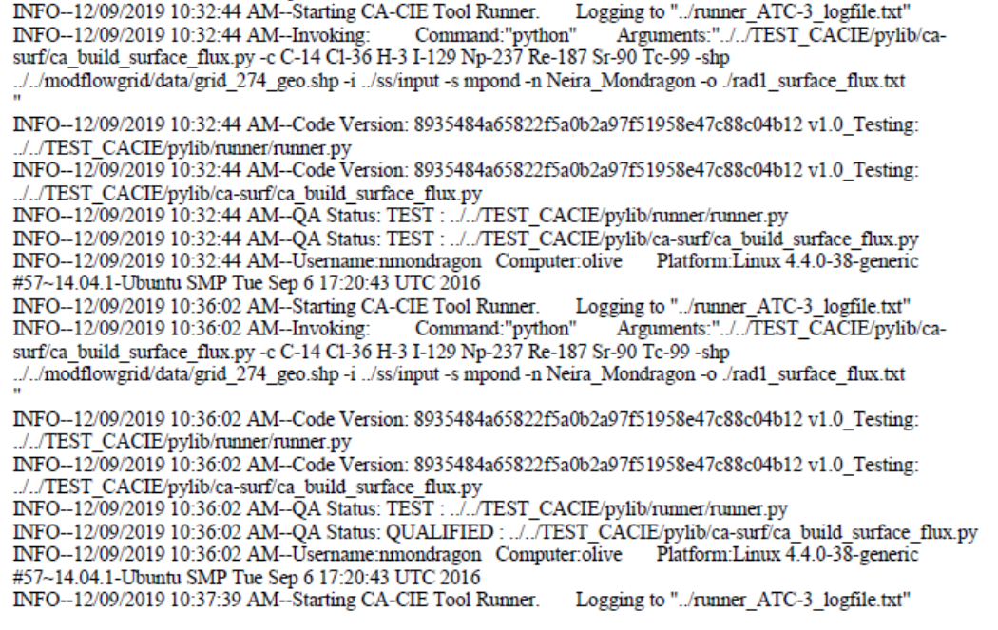



| **Table A-3. Tool Runner Acceptance Test Plan Case 3: Linux Platform** | | | |
| --- | --- | --- | --- |
| **Tool Runner Acceptance Testing**  **CACIE-runner.py – TC-3** | | **Date: 12/09/2019** | |
| **Tool Runner File Location for this test:** *olive-srv\samba\backups\CAVE\sara- sandbox\ToolsTesting\runner_atc_testing_model_linux* *runner_ATC-3_logfile.txt* | | **Test Performed By: Neira Mondragon** | |
| **Testing Directory:** *olive-srv\samba\backups\CAVE\sara-sandbox\ToolsTesting\runner_atc_testing_model_linux* | | | |
| **TEST ID** | **Test Case** | | **Test Result  (Pass/Fail)** |
| CACIE-runner.py-TC-3 | *Navigate to the [*Test_Repo_Name*] and add addfile.txt file to directory.*  *TESTER’S NOTES: Entering the following command:*  *touch addfile.txt* | | |
| *Navigate to [Testing_Directory]\ca-surf-test\ subdirectory* | | |
| *Invoke Tool Runner and test tool using runner_run _ATC-3.sh as follows:*  *Enter the following command: ./runner_run_ATC-3.sh*  *TESTER’S NOTES: check* | | |
| Verify that [Testing_Directory]\runner_ATC-3_logfile.txt documents that the Tool Runner and test tool QA Status is TEST | | Pass |
| *Delete addfile.txt file from directory.*  *TESTER’S NOTES: This added file is in the Test_Repo_Name (TEST_CACIE), navigated back to this directory and entered the following command:*  Rm addfile.txt | | |
| *Navigated back to the [Testing_Directory]\ca-surf-test before this next step.*  *Invoke Tool Runner and test tool using runner_run _ATC-3.sh as follows:*  *Enter the following command: ./runner_run_ATC-3.sh*  *TESTER’S NOTES: check* | | |
| Verify that runner_atc_testing_model\runner_ATC-3_logfile.txt documents that Tool Runner QA Status is TEST  NOTE: Tool Runner is not on the approved tool list in the test repository—see \[Test_Repo_Name]\pylib\runner\config.json to verify | | *Pass* |
| Verify that runner_atc_testing_model\runner_ATC-3_logfile.txt documents that the invoked tool QA Status is QUALIFIED  NOTE: Invoked tool is on the approved tool list in the test repository—see [Test_Repo_Name]\pylib\runner\config.json to verify | | *Pass* |
| *Navigate to [Test_Repo_Name]*  *TESTER’S NOTES: check* | | |
| *Enter the following command:*   * *git checkout development*   *TESTER’S NOTES: check* | | |
| *Navigate to [Testing_Directory] \ca-surf-test*  *TESTER’S NOTES: check* | | |
| *Invoke Tool Runner and test tool using runner_run_ATC-3.sh as follows*   * *Enter the following command: ./runner_run_ATC-3.sh*   *TESTER’S NOTES: check* | | |
| Verify that *[Testing_Directory]*\runner_ATC-3_logfile.txt documents that the Tool Runner and test tool QA Status is TEST | | Pass |
| *Navigate to [*Test_Repo_Name*]* | | |
| *Enter the following command:*   * *git checkout master*   *TESTER’S NOTES: check* | | |

**Tool Runner Log**

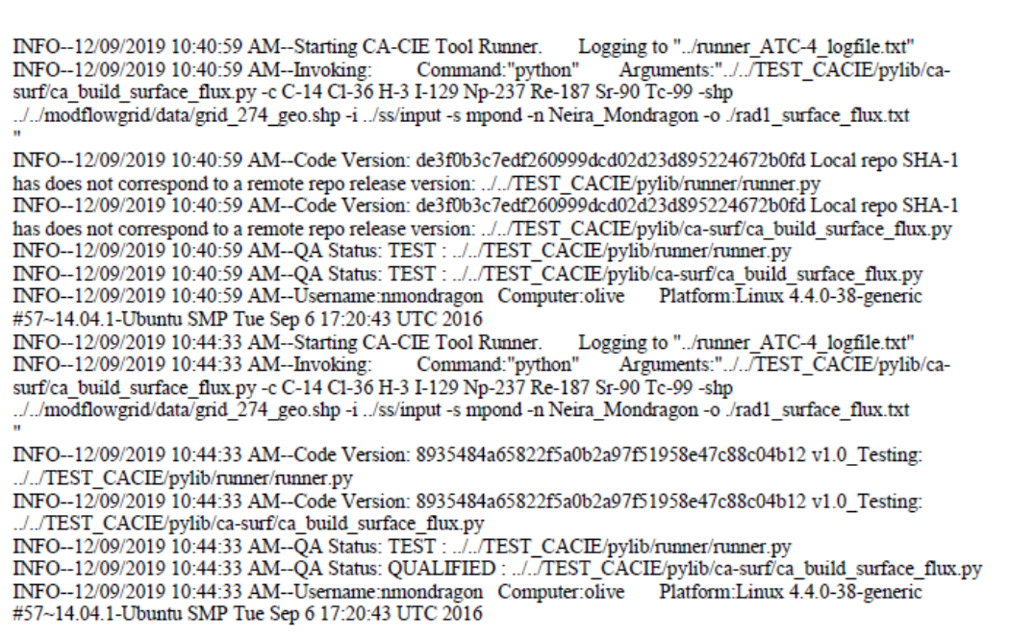

| **Table A-4. Tool Runner Acceptance Test Plan Case 4: Linux Platform** | | | | |
| --- | --- | --- | --- | --- |
| **Tool Runner Acceptance Testing**  **CACIE-runner.py – TC-4** | | **Date: 12/09/2019** | | |
| **Tool Runner File Location for this test:** *olive-srv\samba\backups\CAVE\sara- sandbox\ToolsTesting\runner_atc_testing_model_linux* *runner_ATC-4_logfile.txt* | | **Test Performed By: Neira Mondragon** | | |
| **Testing Directory:** *olive-srv\samba\backups\CAVE\sara-sandbox\ToolsTesting\runner_atc_testing_model_linux* | | | | |
| **TEST ID** | **Test Case** | | **Test Result  (Pass/Fail)** | |
| *CACIE-runner.py-TC-4* | *Navigate to the [*Test_Repo_Name*] and add file addfile.txt to directory*  *TESTER’S NOTES: Enter the following command:*  *Touch addfile.txt* | | | |
| *Enter the following commands:*   * *git add addfile.txt* * *git commit -m ‘test commit’*   *TESTER’S NOTES: check* | | | |
| *Navigate to [Testing_Directory] \ca-surf-test*  *TESTER’S NOTES: check* | | | |
| *Invoke Tool Runner and test tool as follows:*  *Enter the following command: ./runner_run_ATC-4.sh*  *TESTER’S NOTES: check* | | | |
| Verify that [Testing_Directory]\runner_ATC-4_logfile.txt documents that the Code Versions indicate that that local and remote repositories are not synced | | | Pass |
| Verify that [Testing_Directory] \runner_ATC-4_logfile.txt documents that the Tool Runner and test tool QA Status is TEST | | | Pass |
| *Navigate to [*Test_Repo_Name*]* | | | |
| *Enter the following commands:*   * *git log -2* * *git reset --hard [first 6 characters of second commit SHA-1 hash]*   *TESTER’S NOTES: There should be 2: choose the first 6 characters for the earliest time stamp; in this case it would be Sara’s*  *Git log -1 will allow you to see items to double check these last commands* | | | |
| *Navigate to [Testing_Directory] \ca-surf-test* | | | |
| *Invoke Tool Runner and test tool using runner_run _ATC-4.sh as follows:*  *Enter the following command: ./runner_run_ATC-4.sh* | | | |
| Verify that [Testing_Directory] \runner_ATC-4_logfile.txt documents that the local repository and remote repository versions are the same (no “not synced message”) | | | Pass |
| Verify that [Testing_Directory] \runner_ATC-4_logfile.txt documents that Tool Runner QA Status is TEST  NOTE: Tool Runner is not on the approved tool list in the test repository—see \[Test_Repo_Name]\pylib\runner\config.json to verify | | | Pass |
| Verify that [Testing_Directory] \runner_ATC-4_logfile.txt documents that the invoked tool QA Status is QUALIFIED  NOTE: Invoked tool is on the approved tool list in the test repository—see \[Test_Repo_Name]\pylib\runner\config.json to verify | | | Pass |

**Tool Runner Log**

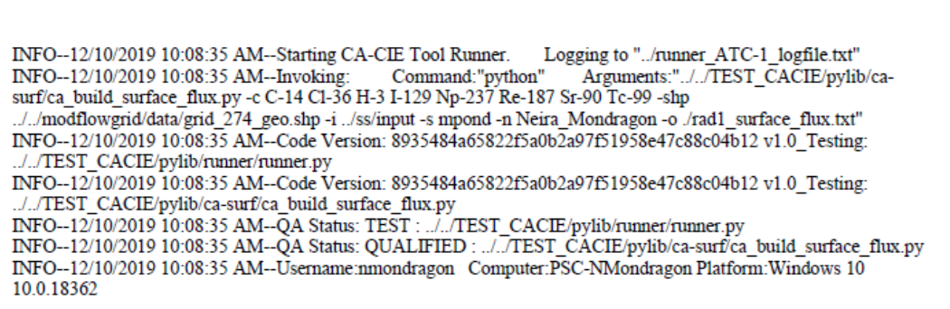

| **Table A-5. Tool Runner Acceptance Test Plan Case 1: Windows Platform** | | | |
| --- | --- | --- | --- |
| **Tool Runner Acceptance Testing**  **CACIE-runner.py – TC-1** | | **Date: 12/10/2019** | |
| **Tool Runner File Location for this test:**  *olive-srv\samba\backups\CAVE\sara-sandbox\ToolsTesting\runner_atc_testing_model_windows* *runner_ATC-1_logfile.txt* | | **Test Performed By: Neira Mondragon** | |
| **Testing Directory:** *olive-srv\samba\backups\CAVE\sara-sandbox\ToolsTesting\runner_atc_testing_model_windows* | | | |
| **TEST ID** | **Test Case** | | **Test Result  (Pass/Fail)** |
| *Note [*Test_Repo_Name*] in acceptance test report:*  *TESTER’S NOTES: Z:\CAVE\sara-sandbox\ToolsTesting\TEST_CACIE*  *Note [Testing_Directory] in acceptance test report:*  *TESTER’S NOTES: Z:\CAVE\sara-sandbox\ToolsTesting\runner_atc_testing_model*  *Note Testing platform in acceptance test report:*  *TESTER’S NOTES: Windows* | | | |
| *If testing on Windows, open git bash window in [Test_Repo_Name].*  *Ensure git repository is on “master” branch by entering:*   * *git branch already on master*   *if not on “master” enter the following command:*   * *git checkout master*   *Enter the following command:*  *git pull*  *TESTER’S NOTES: didn’t ask me to enter my login information-just continued*   * *TESTER’S NOTES: Anaconda Powershell Prompt (anaconda3)* | | | |
| CACIE-runner.py-TC-1 | *Navigate* to [Testing_Directory]\ca*-surf-test\ subdirectory* | | |
| *Invoke Tool Runner and test tool using runner_run_ATC-1.bat as follows:*  *Enter the following command: .\runner_run_ATC-1.bat* | | |
| Verify that the [Testing_Directory]\runner_ATC-1_logfile.txt documents user, computer, operating system platform, and datetime stamp | | Pass |
| Verify that [Testing_Directory]\runner_ATC-1_logfile.txt documents the code version of the Tool Runner and test tool | | Pass |
| Verify [Testing_Directory]\runner_ATC-1_logfile.txt documents that the Tool Runner QA Status is TEST  NOTE: Tool Runner is not on the approved tool list in the test repository—see [Test_Repo_Name]\pylib\runner\config.json to verify | | Pass |
| Verify that [Testing_Directory]\runner_ATC-1_logfile.txt documents that the invoked tool QA Status is QUALIFIED  NOTE: Invoked tool is on the approved tool list in the test repository—see [Test_Repo_Name]\pylib\runner\config.json to verify | | Pass |

**Tool Runner Log**

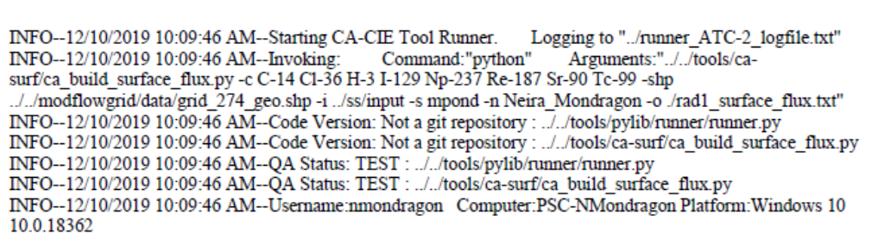

| **Table A-6. Tool Runner Acceptance Test Plan Case 2: Windows Platform** | | | |
| --- | --- | --- | --- |
| **Tool Runner Acceptance Testing**  **CACIE-runner.py – TC-2** | | **Date: 12/10/2019** | |
| **Tool Runner File Location for this test:**  *olive-srv\samba\backups\CAVE\sara-sandbox\ToolsTesting\runner_atc_testing_model_windows* *runner_ATC-2_logfile.txt* | | **Test Performed By: Neira Mondragon** | |
| **Testing Directory:** *olive-srv\samba\backups\CAVE\sara-sandbox\ToolsTesting\runner_atc_testing_model_windows* | | | |
| **TEST ID** | **Test Case** | | **Test Result  (Pass/Fail)** |
| CACIE-runner.py-TC-2 | *Navigate* to [Testing_Directory]\ca*-surf-test\ subdirectory* | | |
| *Invoke Tool Runner and test tool using runner_run _ATC-2.bat as follows:*  *Enter the following command: .\runner_run_ATC-2.bat* | | |
| Verify that [Testing_Directory] \runner_ATC-2_logfile.txt documents that the Tool Runner and test tool are not located in a Git Repository ( ../tools/ subdirectory) “Not a git repository” | | Pass |
| Verify that runner_ATC-2_logfile.txt documents that the Tool Runner and test tool QA Status is TEST | | Pass |

**Tool Runner Log**

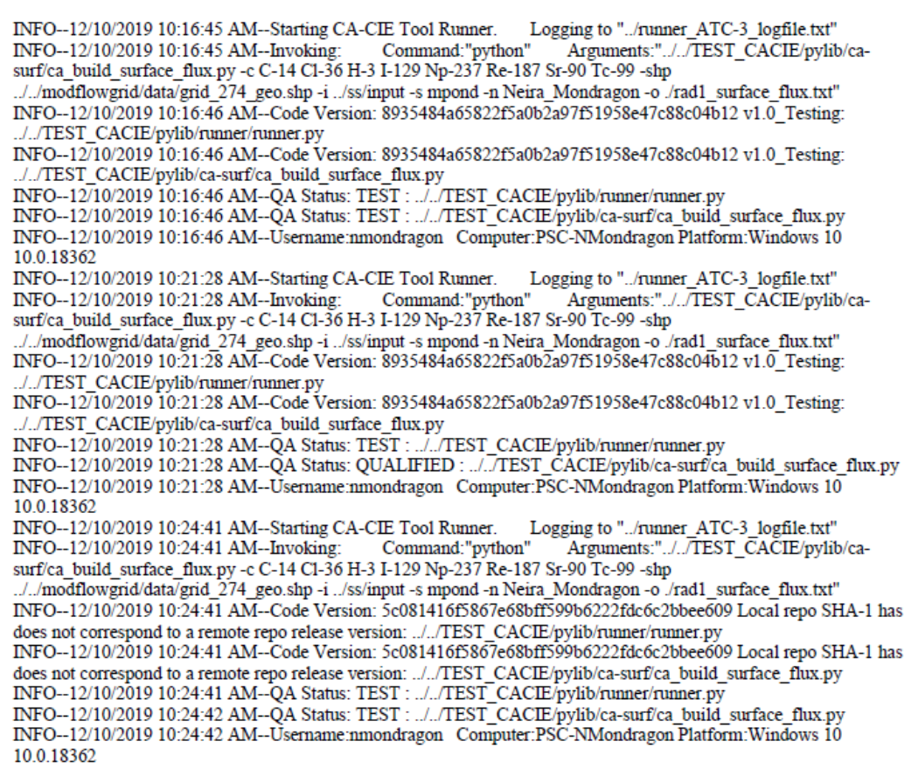

| **Table A-7. Tool Runner Acceptance Test Plan Case 3: Windows Platform** | | | |
| --- | --- | --- | --- |
| **Tool Runner Acceptance Testing**  **CACIE-runner.py – TC-3** | | **Date: 12/10/2019** | |
| **Tool Runner File Location for this test:**  *olive-srv\samba\backups\CAVE\sara-sandbox\ToolsTesting\runner_atc_testing_model_windows* *runner_ATC-3_logfile.txt* | | **Test Performed By: Neira Mondragon** | |
| **Testing Directory:** *olive-srv\samba\backups\CAVE\sara-sandbox\ToolsTesting\runner_atc_testing_model_windows* | | | |
| **TEST ID** | **Test Case** | | **Test Result  (Pass/Fail)** |
| CACIE-runner.py-TC-3 | *Navigate to the [*Test_Repo_Name*] and add addfile.txt file to directory.*  *TESTER’S NOTES: Entering the following command:*  *cd >addfile.txt* | | |
| *Navigate to [Testing_Directory]\ca-surf-test\ subdirectory* | | |
| *Invoke Tool Runner and test tool using runner_run _ATC-3.bat as follows:*  *Enter the following command: .\runner_run_ATC-3.bat* | | |
| Verify that [Testing_Directory]\runner_ATC-3_logfile.txt documents that the Tool Runner and test tool QA Status is TEST | | Pass |
| *Delete addfile.txt file from directory.*  *TESTER’S NOTES: This added file is in the Test_Repo_Name (TEST_CACIE), navigated back to this directory and entered the following command:*  del addfile.txt | | |
| *TESTER’S NOTES: Navigated back to the [Testing_Directory]\ca-surf-test before this next step.*  *Invoke Tool Runner and test tool using runner_run _ATC-3.bat as follows:*  *Enter the following command: .\runner_run_ATC-3.bat* | | |
| Verify that runner_atc_testing_model\runner_ATC-3_logfile.txt documents that Tool Runner QA Status is TEST  NOTE: Tool Runner is not on the approved tool list in the test repository—see \[Test_Repo_Name]\pylib\runner\config.json to verify | | *Pass* |
| Verify that runner_atc_testing_model\runner_ATC-3_logfile.txt documents that the invoked tool QA Status is QUALIFIED  NOTE: Invoked tool is on the approved tool list in the test repository—see [Test_Repo_Name]\pylib\runner\config.json to verify | | *Pass* |
| *Navigate to [Test_Repo_Name]* | | |
| *Enter the following command:*   * *git checkout development* | | |
| *Navigate to [Testing_Directory] \ca-surf-test* | | |
| *Invoke Tool Runner and test tool using runner_run_ATC-3.bat as follows*  *Enter the following command: .\runner_run_ATC-3.bat* | | |
| Verify that *[Testing_Directory]*\runner_ATC-3_logfile.txt documents that the Tool Runner and test tool QA Status is TEST | | Pass |
| *Navigate to [*Test_Repo_Name*]* | | |
| *Enter the following command:*   * *git checkout master* | | |

**Tool Runner Log**

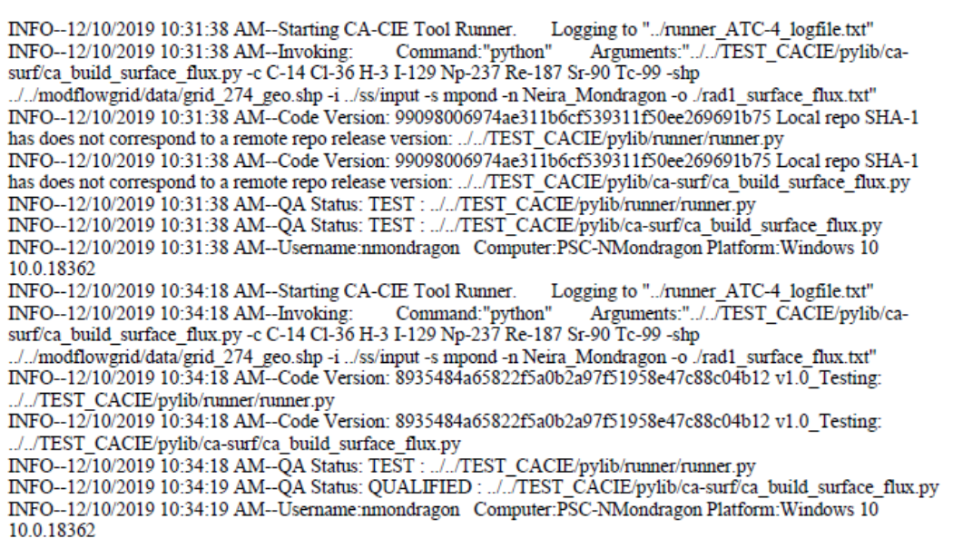

| **Table A-8. Tool Runner Acceptance Test Plan Case 4: Windows Platform** | | | |
| --- | --- | --- | --- |
| **Tool Runner Acceptance Testing**  **CACIE-runner.py – TC-4** | | **Date: 12/10/2019** | |
| **Tool Runner File Location for this test:**  *olive-srv\samba\backups\CAVE\sara-sandbox\ToolsTesting\runner_atc_testing_model_windows* *runner_ATC-4_logfile.txt* | | **Test Performed By: Neira Mondragon** | |
| **Testing Directory:** *olive-srv\samba\backups\CAVE\sara-sandbox\ToolsTesting\runner_atc_testing_model_windows* | | | |
| **TEST ID** | **Test Case** | | **Test Result  (Pass/Fail)** |
| *CACIE-runner.py-TC-4* | *Navigate to the [*Test_Repo_Name*] and add file addfile.txt to directory*  *TESTER’S NOTES: Enter the following command:*  *cd >addfile.txt* | | |
| *Enter the following commands:*   * *git add addfile.txt* * *git commit -m ‘test commit’* | | |
| *Navigate to [Testing_Directory] \ca-surf-test* | | |
| *Invoke Tool Runner and test tool as follows:*  *Enter the following command: .\runner_run_ATC-4.bat* | | |
| Verify that [Testing_Directory]\runner_ATC-4_logfile.txt documents that the Code Versions indicate that that local and remote repositories are not synced | | Pass |
| Verify that [Testing_Directory] \runner_ATC-4_logfile.txt documents that the Tool Runner and test tool QA Status is TEST | | Pass |
| *Navigate to [*Test_Repo_Name*]* | | |
| *Enter the following commands:*   * *git log -2* * *git reset --hard [first 6 characters of second commit SHA-1 hash]*   *There should be 2: choose the first 6 characters for the earliest time stamp; in this case it would be Sara’s*  *Git log -1 will allow you to see items to double check these last commands* | | |
| *Navigate to [Testing_Directory] \ca-surf-test* | | |
| *Invoke Tool Runner and test tool using runner_run _ATC-4.bat as follows:*  *Enter the following command: .\runner_run_ATC-4.bat* | | |
| Verify that [Testing_Directory] \runner_ATC-4_logfile.txt documents that the local repository and remote repository versions are the same (no “not synced message”) | | Pass |
| Verify that [Testing_Directory] \runner_ATC-4_logfile.txt documents that Tool Runner QA Status is TEST  NOTE: Tool Runner is not on the approved tool list in the test repository—see \[Test_Repo_Name]\pylib\runner\config.json to verify | | Pass |
| Verify that [Testing_Directory] \runner_ATC-4_logfile.txt documents that the invoked tool QA Status is QUALIFIED  NOTE: Invoked tool is on the approved tool list in the test repository—see \[Test_Repo_Name]\pylib\runner\config.json to verify | | Pass |

**Appendix B**

**Installation Test Plan**

**Tool Runner Log—Windows**

INFO--01/16/2020 02:23:27 PM--Starting CA-CIE Tool Runner. Logging to "./testlog/CACIETools_v1.0_installtest_logfile.txt"

INFO--01/16/2020 02:23:27 PM--Invoking: Command:"python" Arguments:"S:/PSC/!HANFORD/ICF/CA-CIE-Tools/CA-CIE-Tools/pylib/fingerprint/fingerprint.py ./TestFolder_1 -o ./testlog/runner.py_IT-1_windows_fingerprint.txt"

INFO--01/16/2020 02:23:28 PM--Code Version: 53308176b389f2fa9adf86a01da71851b3b09d5d v1.0: S:/PSC/!HANFORD/ICF/CA-CIE-Tools/CA-CIE-Tools/pylib/runner/runner.py

INFO--01/16/2020 02:23:28 PM--Code Version: 53308176b389f2fa9adf86a01da71851b3b09d5d v1.0: S:/PSC/!HANFORD/ICF/CA-CIE-Tools/CA-CIE-Tools/pylib/fingerprint/fingerprint.py

INFO--01/16/2020 02:23:30 PM--QA Status: QUALIFIED : S:/PSC/!HANFORD/ICF/CA-CIE-Tools/CA-CIE-Tools/pylib/runner/runner.py

INFO--01/16/2020 02:23:30 PM--QA Status: QUALIFIED : S:/PSC/!HANFORD/ICF/CA-CIE-Tools/CA-CIE-Tools/pylib/fingerprint/fingerprint.py

INFO--01/16/2020 02:23:30 PM--Username:rdockter Computer:PSC-Polonium Platform:Windows 10 10.0.18362

INFO--01/16/2020 02:27:13 PM--Starting CA-CIE Tool Runner. Logging to "./testlog/CACIETools_v1.0_installtest_logfile.txt"

INFO--01/16/2020 02:27:13 PM--Invoking: Command:"python" Arguments:"S:/PSC/!HANFORD/ICF/CA-CIE-Tools/CA-CIE-Tools/pylib/fingerprint/fingerprint.py ./TestFolder_1 -o ./testlog/fingerprint.py_IT-1_windows_fingerprint.txt"

INFO--01/16/2020 02:27:14 PM--Code Version: 53308176b389f2fa9adf86a01da71851b3b09d5d v1.0: S:/PSC/!HANFORD/ICF/CA-CIE-Tools/CA-CIE-Tools/pylib/runner/runner.py

INFO--01/16/2020 02:27:15 PM--Code Version: 53308176b389f2fa9adf86a01da71851b3b09d5d v1.0: S:/PSC/!HANFORD/ICF/CA-CIE-Tools/CA-CIE-Tools/pylib/fingerprint/fingerprint.py

INFO--01/16/2020 02:27:16 PM--QA Status: QUALIFIED : S:/PSC/!HANFORD/ICF/CA-CIE-Tools/CA-CIE-Tools/pylib/runner/runner.py

INFO--01/16/2020 02:27:17 PM--QA Status: QUALIFIED : S:/PSC/!HANFORD/ICF/CA-CIE-Tools/CA-CIE-Tools/pylib/fingerprint/fingerprint.py

INFO--01/16/2020 02:27:17 PM--Username:rdockter Computer:PSC-Polonium Platform:Windows 10 10.0.18362

**Tool Runner Log—Linux**

INFO--01/16/2020 02:44:41 PM--Starting CA-CIE Tool Runner. Logging to "./testlog/CACIETools_v1.0_installtest_logfile.txt"

INFO--01/16/2020 02:44:41 PM--Invoking: Command:"python" Arguments:"../../../../../../opt/tools/pylib/fingerprint/fingerprint.py ./TestFolder_1 -o ./testlog/runner.py_IT-1_linux_fingerprint.txt"

INFO--01/16/2020 02:44:41 PM--Code Version: 53308176b389f2fa9adf86a01da71851b3b09d5d v1.0: ../../../../../../opt/tools/pylib/fingerprint/fingerprint.py

INFO--01/16/2020 02:44:41 PM--Code Version: 53308176b389f2fa9adf86a01da71851b3b09d5d v1.0: ../../../../../../opt/tools/pylib/runner/runner.py

INFO--01/16/2020 02:44:42 PM--QA Status: QUALIFIED : ../../../../../../opt/tools/pylib/fingerprint/fingerprint.py

INFO--01/16/2020 02:44:42 PM--QA Status: QUALIFIED : ../../../../../../opt/tools/pylib/runner/runner.py

INFO--01/16/2020 02:44:42 PM--Username:rdockter Computer:olive Platform:Linux 4.4.0-38-generic #57~14.04.1-Ubuntu SMP Tue Sep 6 17:20:43 UTC 2016

INFO--01/16/2020 02:45:27 PM--Starting CA-CIE Tool Runner. Logging to "./testlog/CACIETools_v1.0_installtest_logfile.txt"

INFO--01/16/2020 02:45:27 PM--Invoking: Command:"python" Arguments:"../../../../../../opt/tools/pylib/fingerprint/fingerprint.py ./TestFolder_1 -o ./testlog/fingerprinter.py_IT-1_linux_fingerprint.txt"

INFO--01/16/2020 02:45:27 PM--Code Version: 53308176b389f2fa9adf86a01da71851b3b09d5d v1.0: ../../../../../../opt/tools/pylib/fingerprint/fingerprint.py

INFO--01/16/2020 02:45:27 PM--Code Version: 53308176b389f2fa9adf86a01da71851b3b09d5d v1.0: ../../../../../../opt/tools/pylib/runner/runner.py

INFO--01/16/2020 02:45:27 PM--QA Status: QUALIFIED : ../../../../../../opt/tools/pylib/fingerprint/fingerprint.py

INFO--01/16/2020 02:45:27 PM--QA Status: QUALIFIED : ../../../../../../opt/tools/pylib/runner/runner.py

INFO--01/16/2020 02:45:27 PM--Username:rdockter Computer:olive Platform:Linux 4.4.0-38-generic #57~14.04.1-Ubuntu SMP Tue Sep 6 17:20:43 UTC 2016

INFO--01/16/2020 02:50:31 PM--Starting CA-CIE Tool Runner. Logging to "./testlog/CACIETools_v1.0_installtest_logfile.txt"

| **Table B-1. Tool Runner Installation Test Plan—Linux** | | | | | |
| --- | --- | --- | --- | --- | --- |
| **Tool Runner Installation Testing**  **CACIE-runner.py – IT-1** | | | **Date: 01/16/2020** | | |
| **Tool Runner File Location for this test:**  \\olive\backups\CAVE\CA-CIE-Tools-TestEnv\CA-CIE-Tools_v1.0_install_tests\testlog\CACIETools_v1.0_installtest_logfile.txt | | | **Test Performed By: Rand Dockter** | | |
| **Testing Directory:** \\olive\backups\CAVE\CA-CIE-Tools-TestEnv\CA-CIE-Tools_v1.0_install_tests | | | | | |
| **TEST ID** | | **Test Case** | | | **Test Result  (Pass/Fail)** |
| CACIE-runner.py -IT-1 | *Navigate to [Testing_Directory]* | | | | |
| *Invoke Tool Runner and test tool as follows:*  *Enter the following command: ./runner_run_IT-1_linux.sh* | | | | |
| Verify Tool Runner is invoked and executes | | | PASS | |
| Verify invoked tool executes | | | PASS | |

| **Table B-2. Tool Runner Installation Test Plan—Windows** | | | |
| --- | --- | --- | --- |
| **Tool Runner Installation Testing**  **CACIE-runner.py – IT-1** | | **Date: 01/16/2020** | |
| **Tool Runner File Location for this test:**  \\olive\backups\CAVE\CA-CIE-Tools-TestEnv\CA-CIE-Tools_v1.0_install_tests\testlog\CACIETools_v1.0_installtest_logfile.txt | | **Test Performed By: Randy Dockter** | |
| **Testing Directory:**  \\olive\backups\CAVE\CA-CIE-Tools-TestEnv\CA-CIE-Tools_v1.0_install_tests | | | |
| **TEST ID** | **Test Case** | | **Test Result  (Pass/Fail)** |
| CACIE-runner.py -IT-1 | *Navigate to [Testing_Directory]* | | |
| *Invoke Tool Runner and test tool using runner_run_IT-1_windows.bat as follows:*  *Enter the following command: ./runner_run_IT-1_windows.bat* | | |
| Verify Tool Runner is invoked and executes | | PASS |
| Verify invoked tool executes | | PASS |

**Appendix C**

**QA Checklist**

